Task on Docker-2
- Create a tomcat container on 8080 and deploy sample application in tomcat.
Create an instance and login to it
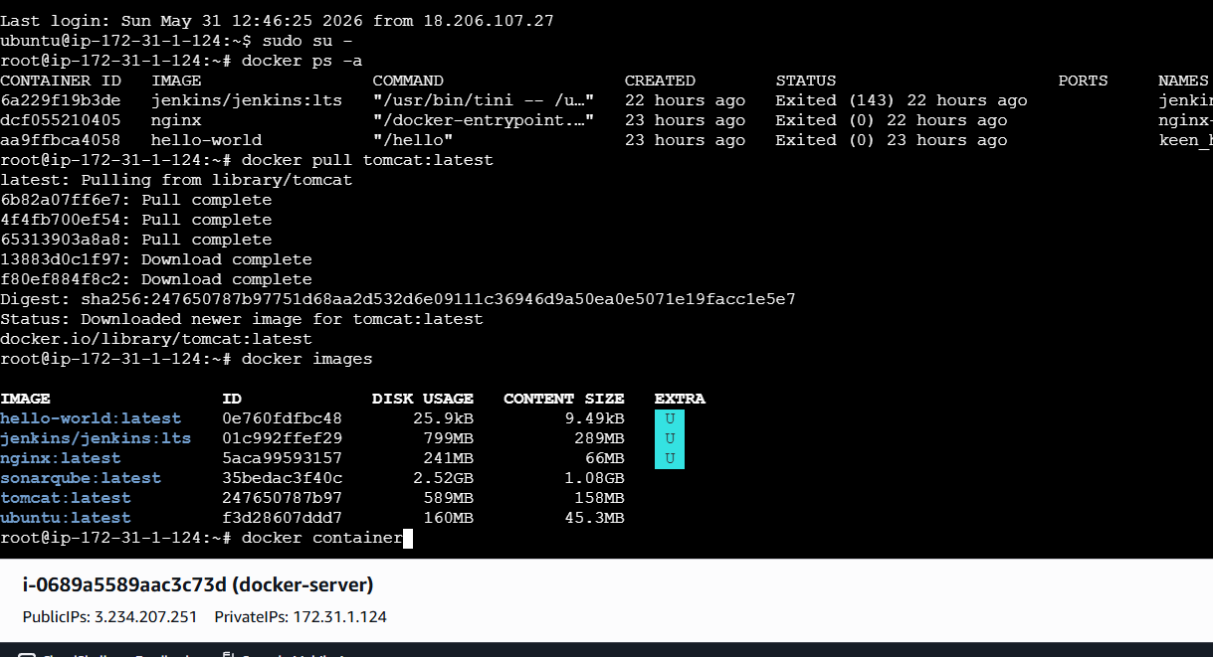
docker pull tomcat
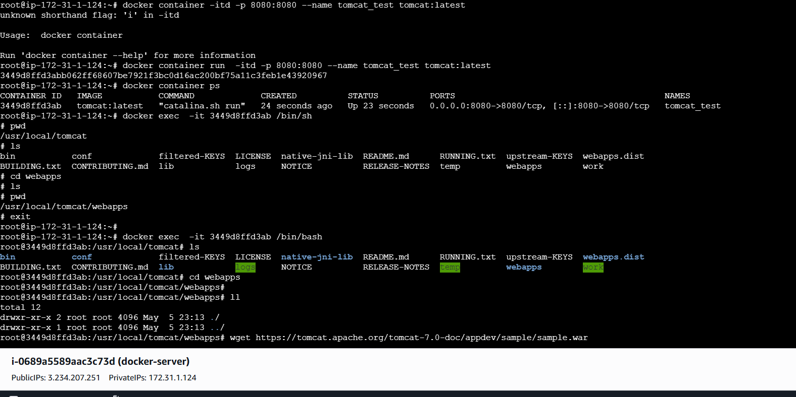
wget https://tomcat.apache.org/tomcat-6.0-doc/appdev/sample/sample.war

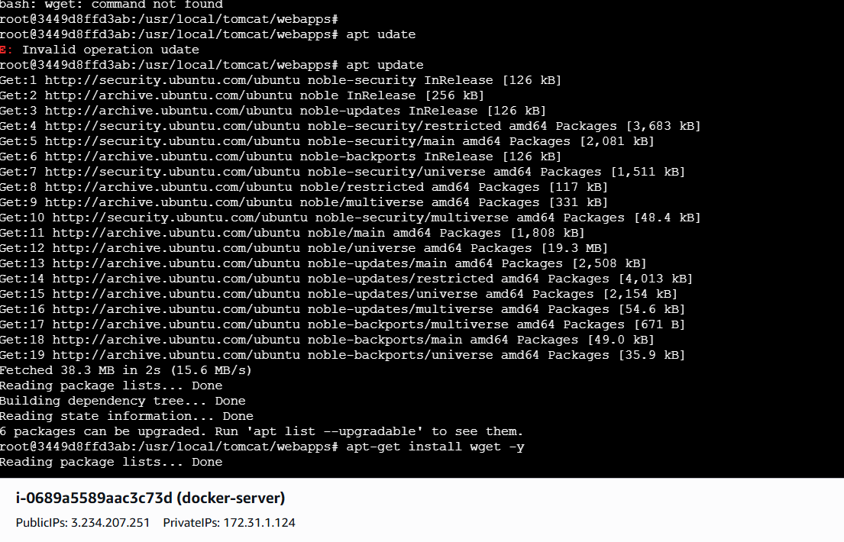

apt-get update
apt-get install -y wget

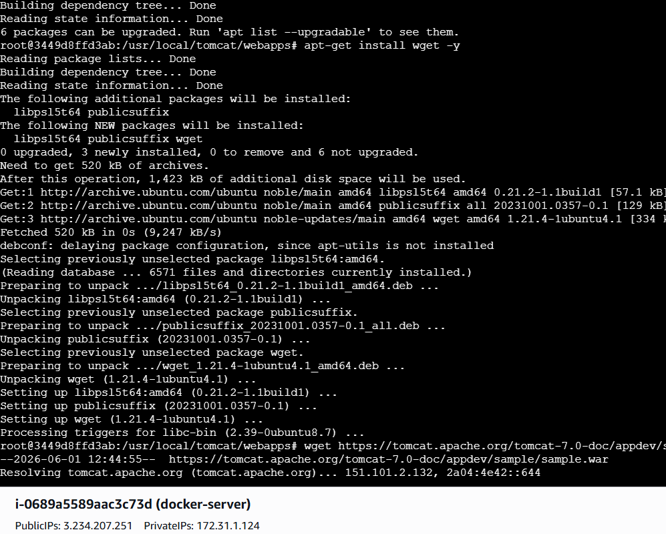
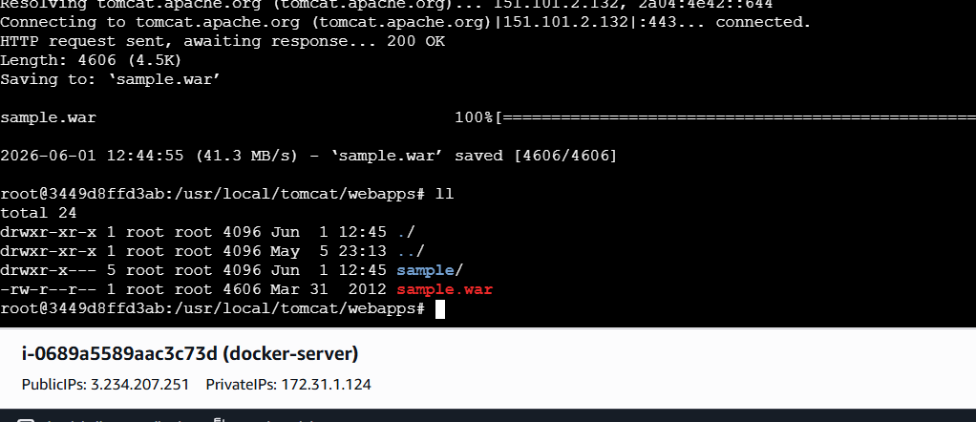
Now check the url

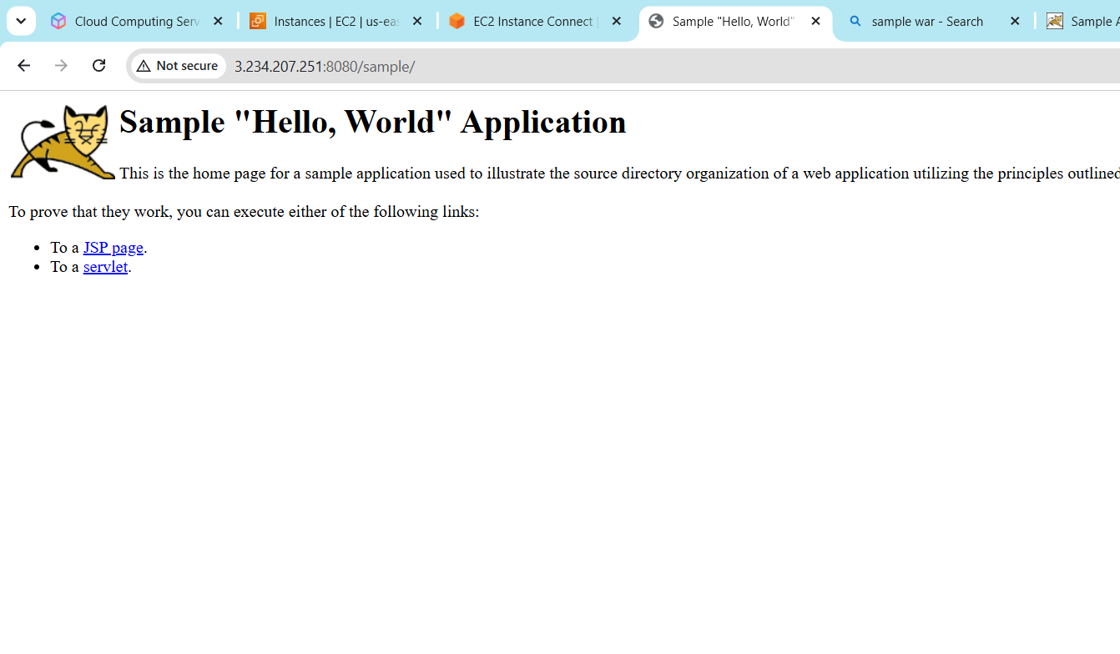
- Create volume and deploy tomcat container on port 8081.
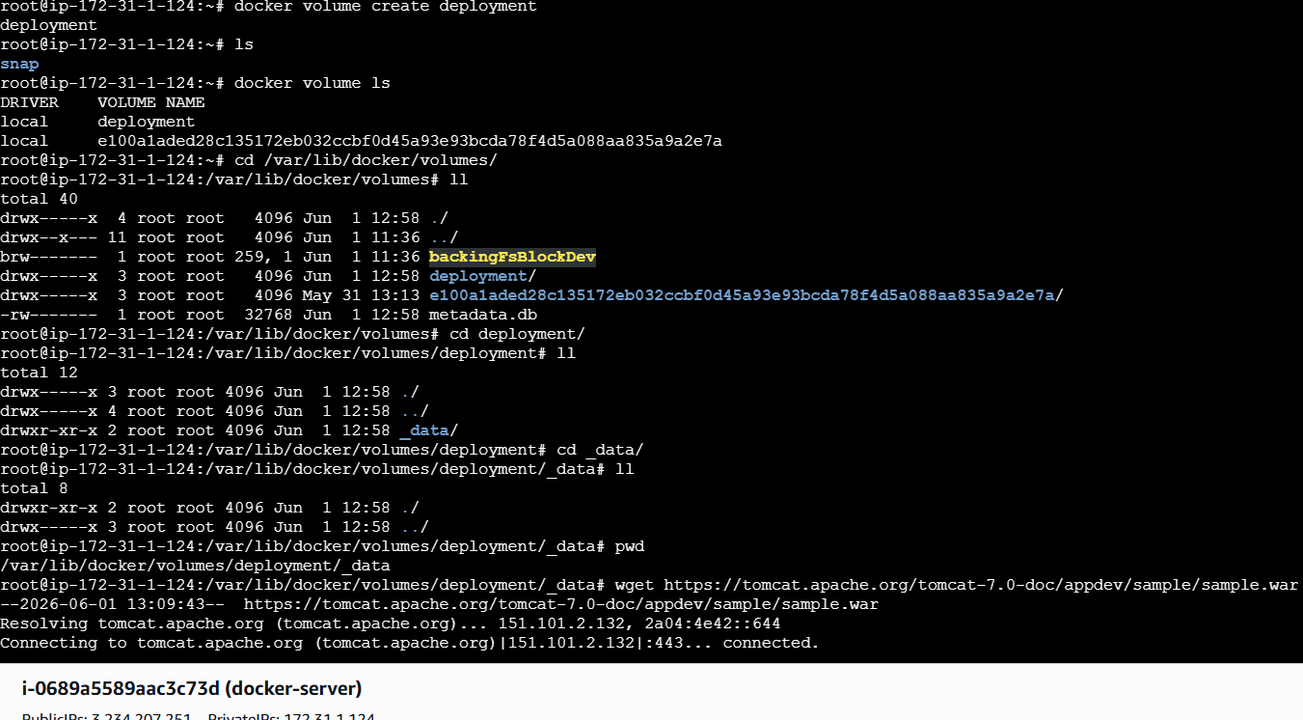
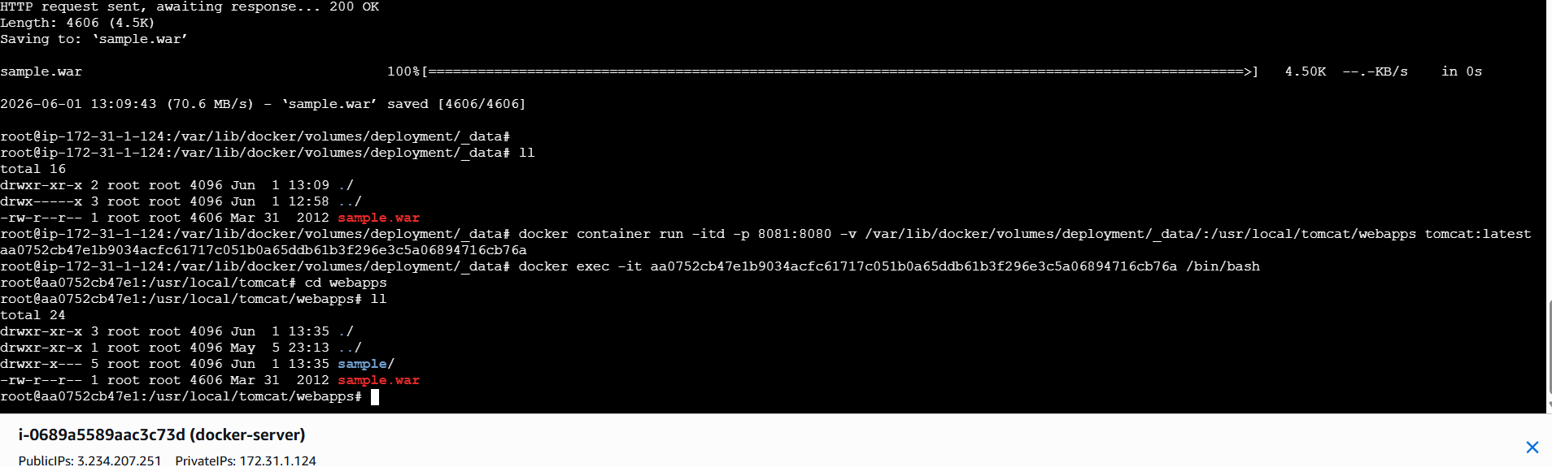

Now the port number is changed to 8081 and the volume is mapped to tomcat
container
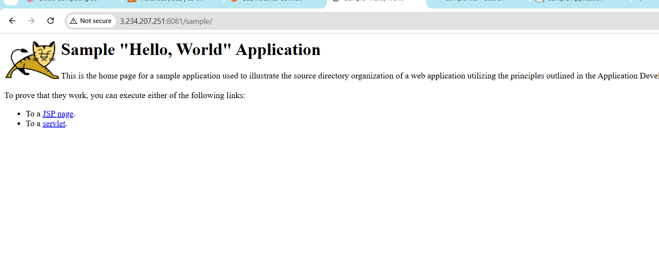

- Limit the nginx container to 500 MB.
docker container run -itd -p 80:80 –memory=500m nginx
changed the limit of nginx to 500mb
––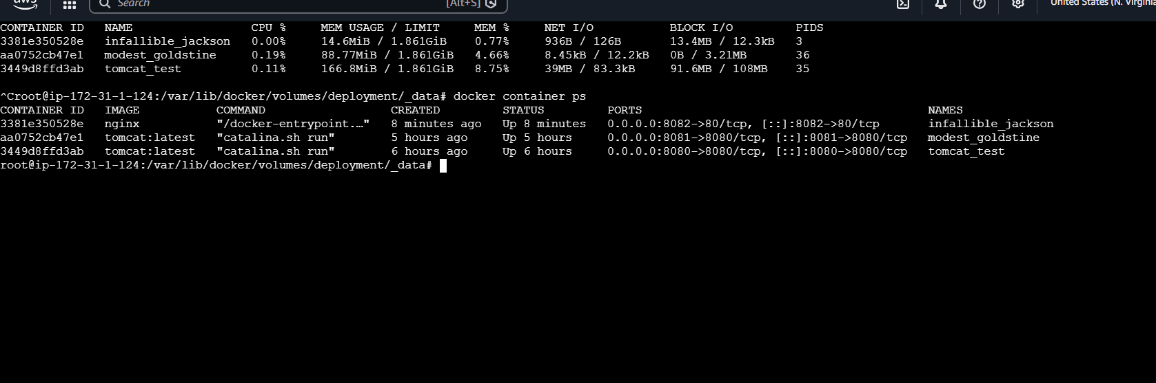
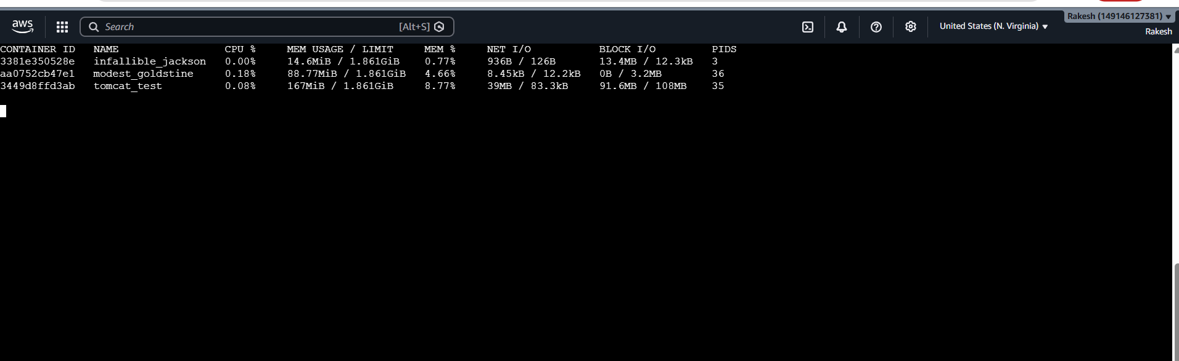
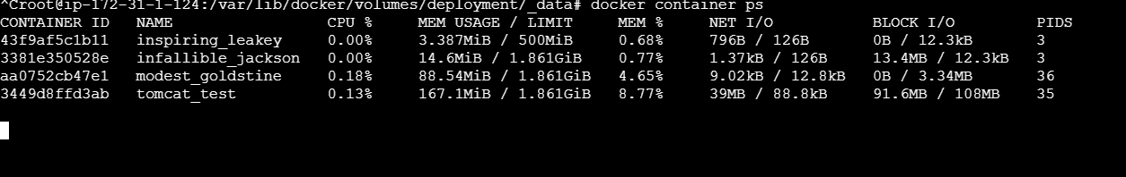

- Create a sample docker file using below instructions.
  - Base module as amazonlinux:latest
  - Maintainer you name
  - Install nginx
  - COPY one index.html file to image
  - Expose on port 80
  - Command to start the nginx container
Lets create an Index.html file first
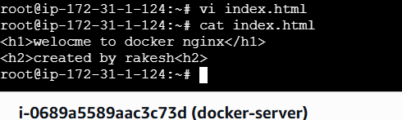
Now lets create a docker file

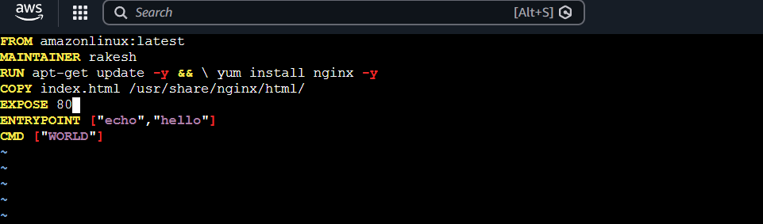
Now lets build
docker build -t javed:v1 .
Step 1 and 2
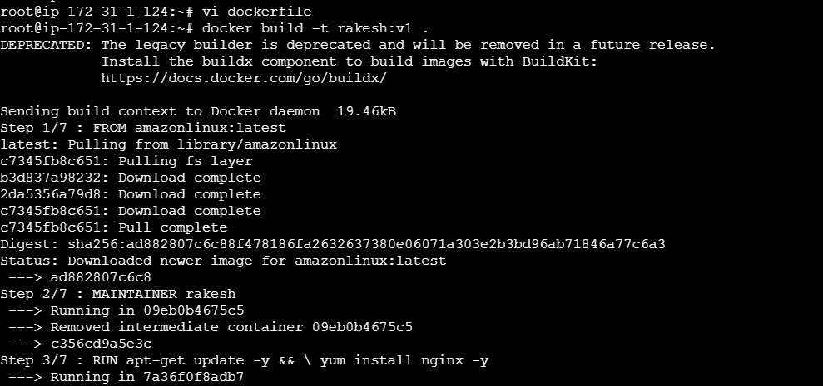
Step -3
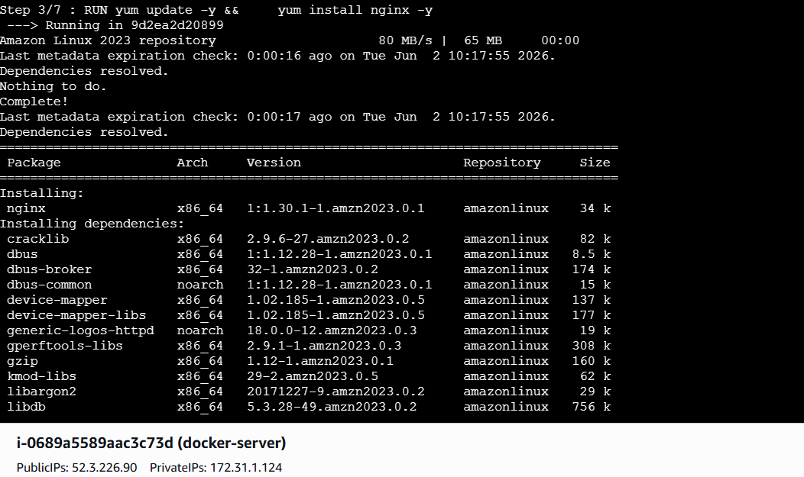
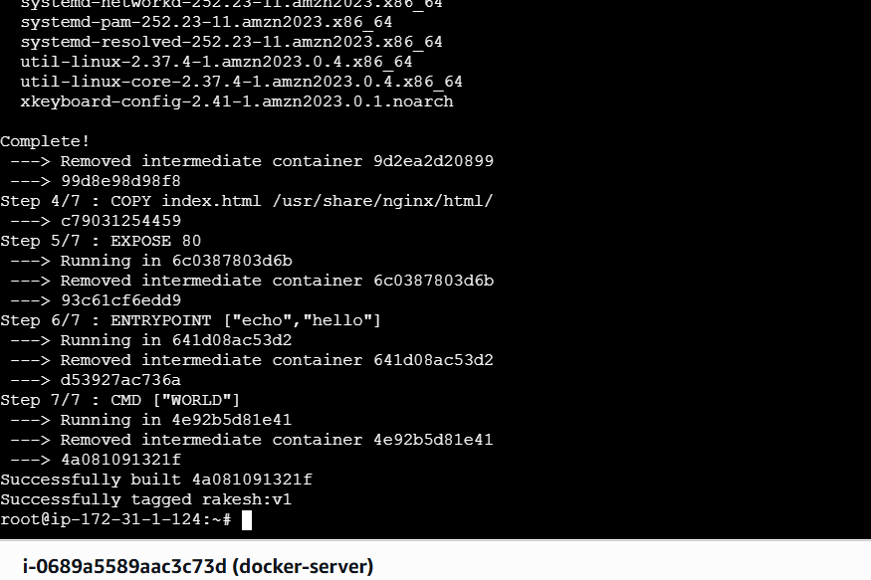
Now Lets run
docker run -d \
--name nginx \
-p 8082:80 \
rakesh:v1
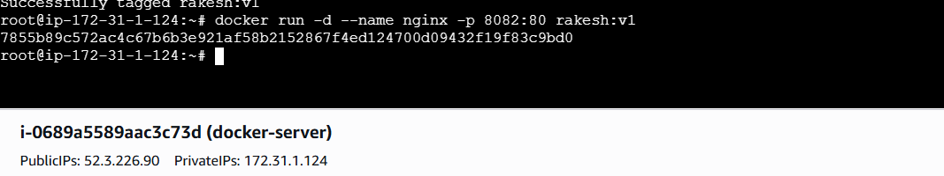

Docker images
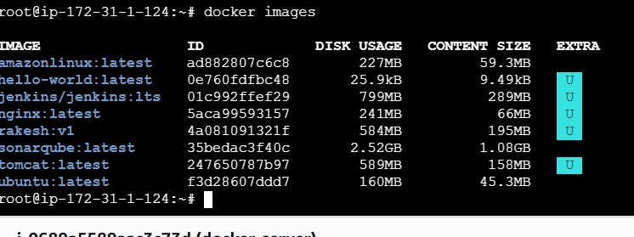
Lets check in browser
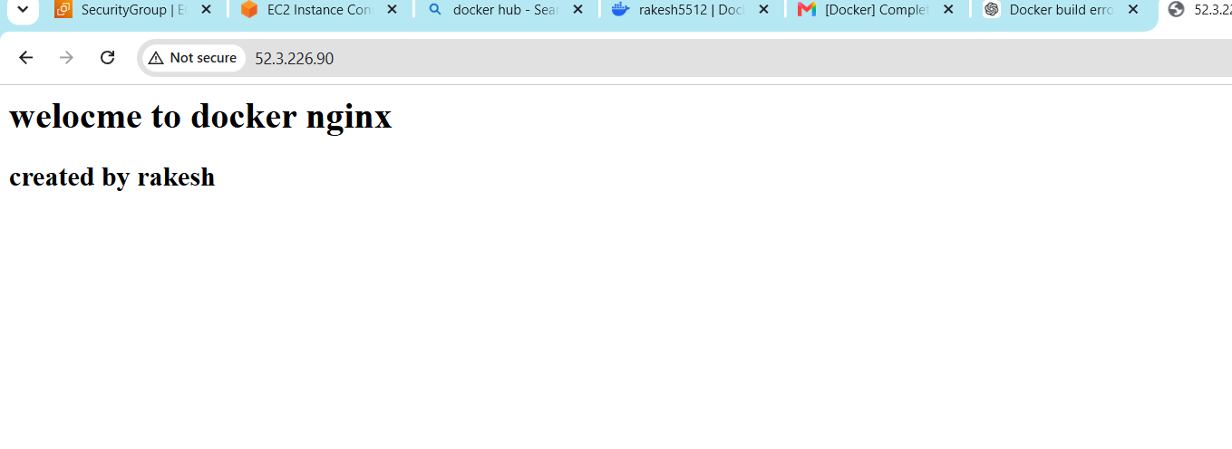

- Push image to Docker hub
Create a repo in Docker hub
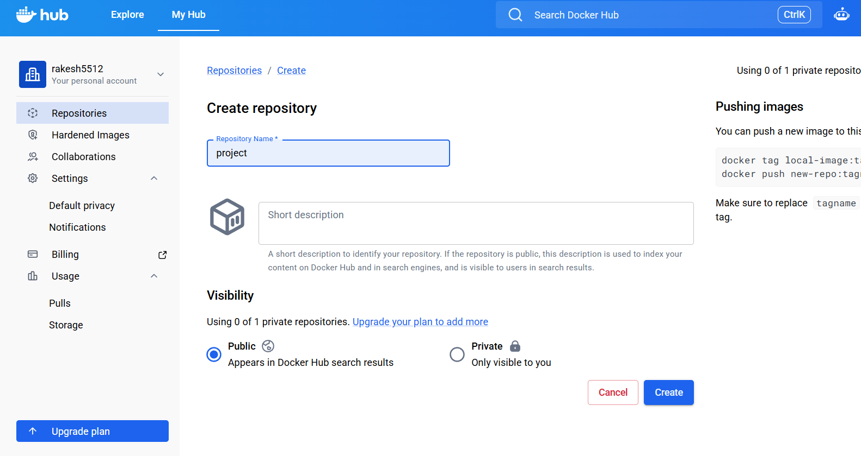
Now lets rename our image name by using command
docker tag rakesh:v1 rakesh5512/project:v1and to push the image to repository use the
command
docker push rakesh5512/project:v1
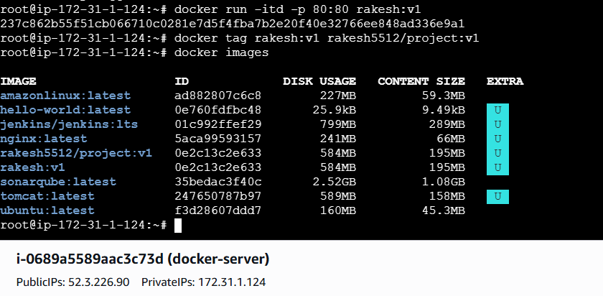
Now lets check in the Docker Hub
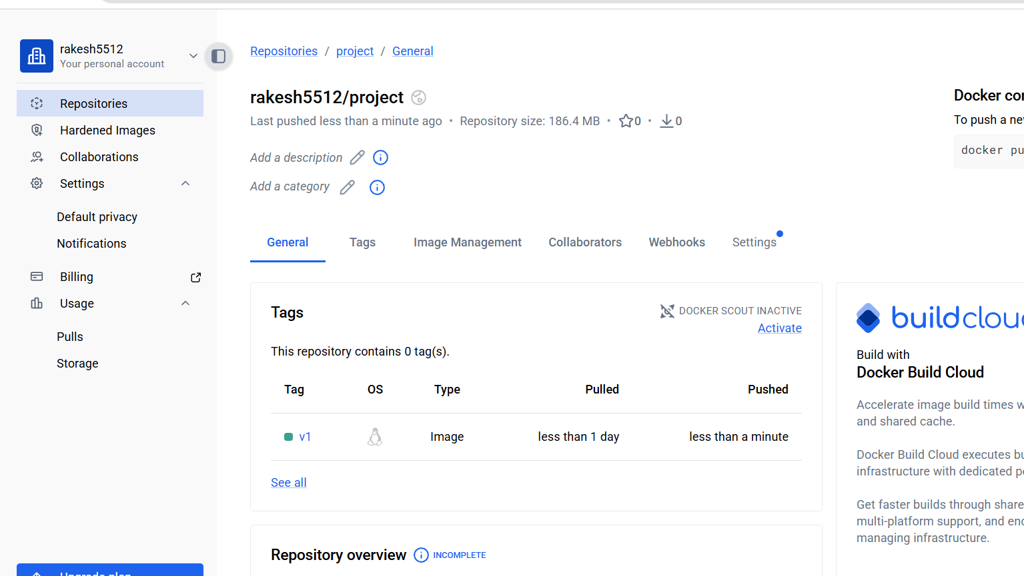

- push image to AWS ECR
Lets create a repo in ECR
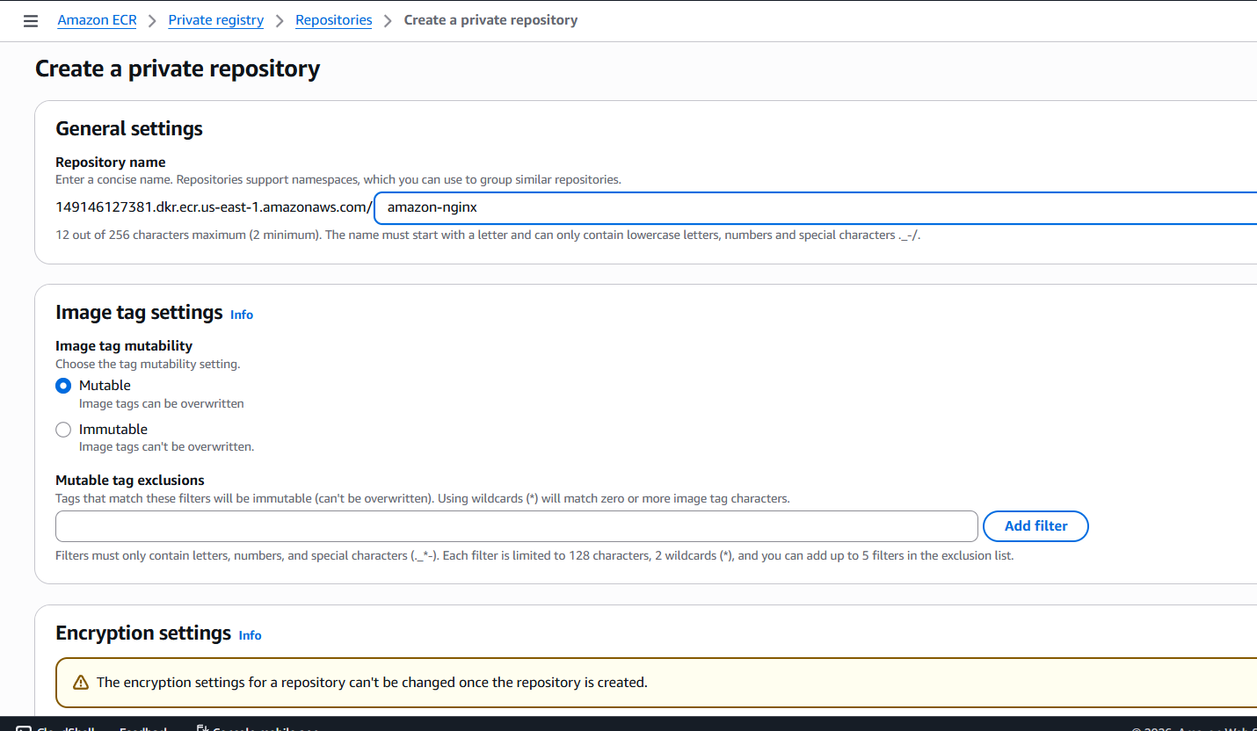
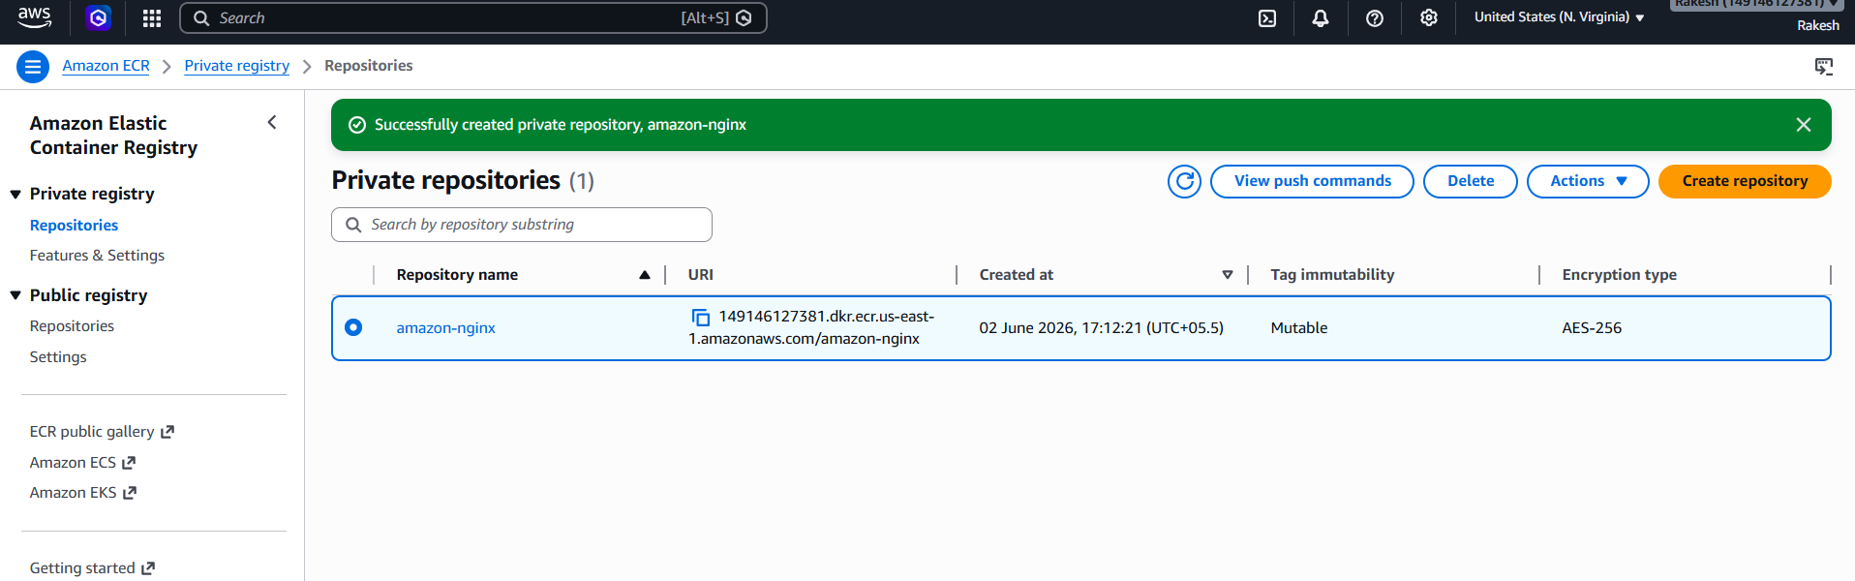
Install AWS CLI using command
apt install awscli -y

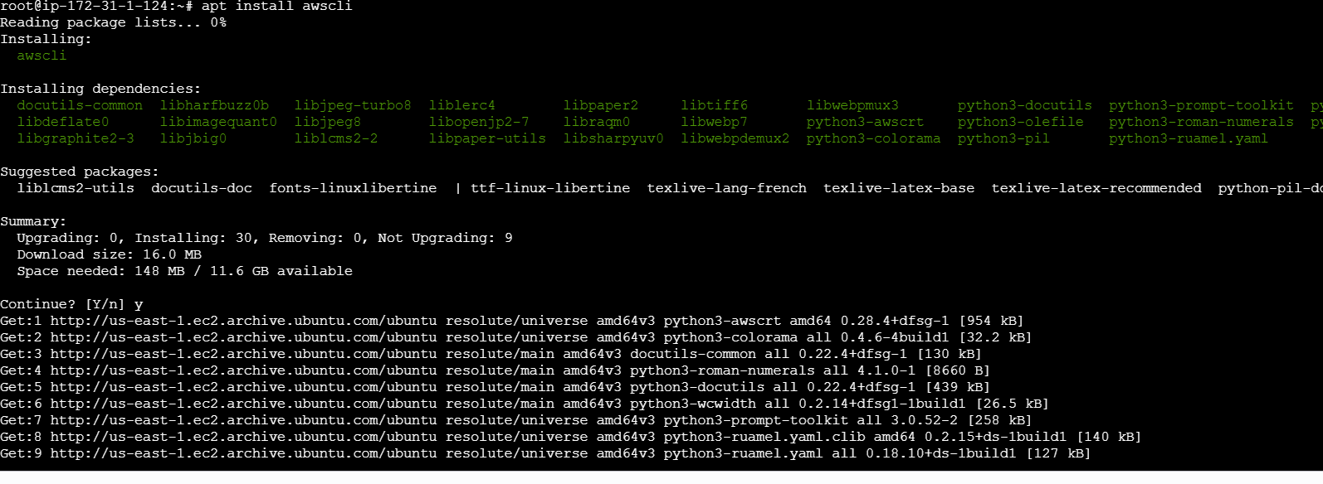
Aws configure
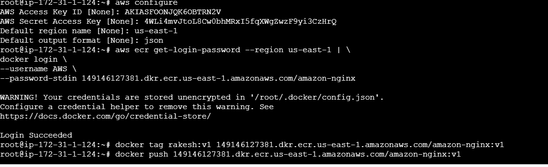
Login using the below command
aws ecr get-login-password --region us-east-1 | \
docker login \
--username AWS \
--password-stdin
149146127381.dkr.ecr.us-east-1.amazonaws.com/amazon-nginx --
U willget this from the URI in the below image
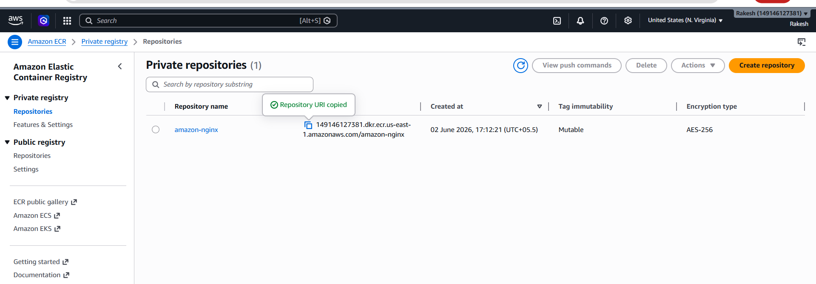
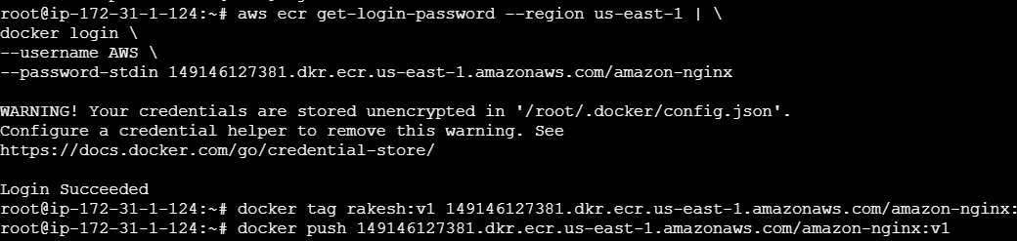
Now lets rename our image to repo name by using command
docker tag rakesh:v1 149146127381.dkr.ecr.us-east-1.amazonaws.com/amazon-nginx:v1
Now lets push to our ECR repo by using command
docker push 149146127381.dkr.ecr.us-east-1.amazonaws.com/amazon-nginx:v1
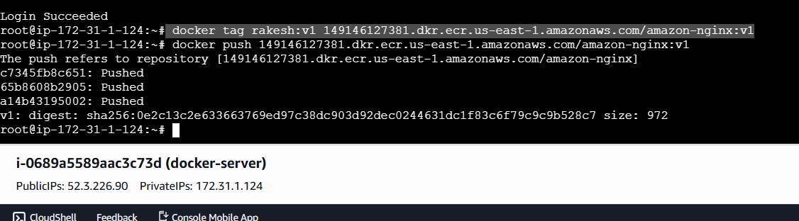

Lets check in the AWS ECR
It has been pushed successfully
